## *2017 Pink Fiddle*

## Rosé of Pinot noir



KATHY’S CORNER

*Join us every February for our Annual Pink Fiddle Release Celebration, always on the Saturday before Valentine’s Day, where we party with a rosé-paired menu and an abundance of flowing Pink Fiddle.*

* **Vinification:** Fermented dry,

partial-malo, 100% stainless steel

* **Vintage:** 100% 2017
* **Varietal:** 100% Pinot Noir
* **AVA:** 100% Sta. Rita Hills, Santa Barbara County, Pinot-central!
* **Clones:** 113, 4 & 667
* **Harvest Dates:** August 23 & 28, 2017. Night harvested, hand-picked and hand-sorted in the vineyard.
* Alc 13.0%, pH 3.31, TA 6.00 g/L
* 273 Cases Produced

**Saignee or not?**

*It’s not simple “bleed” juice. We taste for distinctive blocks at Fiddlestix in the nascent stage of the vintage, when sugars are low, natural acidity is high, and the grapes have begun to mature in color and flavor. Each block and clonal selection is targeted specifically for this wine by expressing early flavor maturity at lower sugar (and thus lower alcohol), and yielding delicacy in the finished wine.*

**Color Profile**

*Grape skin contact with the grape juice is limited to less than 24 hours to produce its brilliant, light cherry blossom hue. After gentle destemming and this relatively short skin contact, we capture the “free run” juice and combine it with the lightly pressed skins that were allowed limited tannin extraction. Cold fermentation in stainless steel preserves the fruity & spicy essence of Pinot Noir, and retains the delicacy of the early pick.*

**Flavor Profile**

*A perfectly delicate bouquet of signature Sta. Rita Hills black cherry, infused with dried cranberries, pomegranate and a touch of cinnamon spice. This wine uniquely straddles the line between cheerful brightness and mouth-filling smoothness.*

**Balanced**

*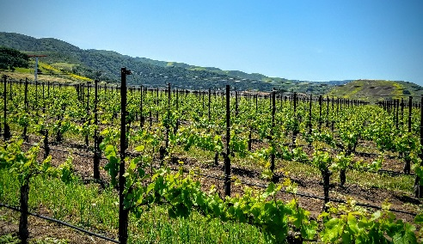The fresh and exciting, ‘first-peek’ at the 2017 vintage. Started like a red wine and finished like a white wine, without sacrificing any of the complexity and nuance that is expected of Fiddlestix Vineyard. Here in the Sta. Rita Hills cool climate conveys great acidity. We ferment dry like in Provence, making Pink Fiddle an almost serious wine …or as serious as you want it to be.*

**Food Pairings**

*It loves the grill, loves ginger and fennel or aged goat cheese, perfect with salade niçoise, or pork chile verde with lavender, and it simply screams for garden-fresh strawberries with aged balsamic and freshly whipped cream.*

**Ageability**

*We recommend drinking this wine within the first 2 years of its life to enjoy its delicacy and freshness.*